# Department of Computing

**CS 354: Compiler Construction**

**Class:** BSCS-6C

# Lab [05]: Lexical Analysis with Flex

**Date: 5**th Nov, 2019

**Time:** [2:00pm – 5:00pm]

# Group Lab

Abdul Ghaffar Kalhoro 194699

Ahmad Amjad Mughal 121672

**BSCS-6C**

# 

# Lab [04]: Lexical Analysis with Flex

**Introduction**

The lexical analyzer is the part of the compiler that reads the source text, it may also perform certain secondary tasks at the user interface. One such task is stripping out comments and white space in the form of blanks, tabs and new line characters, from the source program. Another is correlating error messages from the compiler with the source program i.e. keeping a correspondence between errors and source line numbers.

**Objectives**

1. Successful understanding/implementation of basic Lexical Analysis using flex

**Tools/Software Requirement**

1. flex on Linux or Windows platform

**Description**

Lexical analysis is the process of converting a sequence of characters into a sequence of [tokens](http://en.wikipedia.org/wiki/Lexical_analysis" \l "Token). A program or function which performs lexical analysis is called a lexical analyzer, lexer or scanner. A lexer often exists as a single function which is called by a [parser](http://en.wikipedia.org/wiki/Parser) or another function.

**Lab Tasks**

* **Flex in a Nutshell (tutorial):** Go through the flex.
* Write a flex program to process a pascal-like toy language with the following specifications:
  + Match integers and floating point constants
  + Match Identifiers, starting with lower-case alphabets and allowing for integers in non-starting locations.
  + Keywords: if, then, begin, end, procedure, function
  + Operators: +, -, *, /
  + Skipping of white-space characters i.e. new-line, tabs and spaces
  + Printing of un-recognized characters

Use the following example code to test your lexical analyzer.

|  |
| --- |
| procedure compute  begin  area = 3.141 * radius * radius  end  function main  begin  compute  end |

Your output should resemble:

|  |
| --- |
| A keyword: procedure  An identifier: compute  A keyword: begin  An identifier: area  Unrecognized character: =  A float: 3.141 (3.141)  An operator: *  An identifier: radius  An operator: *  An identifier: radius  A keyword: end  A keyword: function  An identifier: main  A keyword: begin  An identifier: compute  A keyword: end |

* **Postfix formula evaluation:** Given an input text containing non-negative integers and three operator i.e. +, - and *, evaluate the given postfix formula using flex based lexical analyzer. For example given the following input:

**44 33 22 * + 1 -**

Your output should resemble:

|  |
| --- |
| 44 0 0 0  33 44 0 0  22 33 44 0  726 44 0 0  770 0 0 0  1 770 0 0  769 0 0 0  result = 769 |

**Flex Installation**

**Command:**

* **sudo apt-get update**
* **sudo apt-get install flex**

**Now the package of flex is installed to your home directory.**

**To check the flex version use following command.**

* **flex --version**

**Source Code task1.l**

**/\*\*\*\*\*\*\*\*\*\*\*\*\*\*\*\*\*\*\*\*\*\*\*\*\*\*\*\*\*\*\*\***

**Task: 1 ~~ Code for PostFix with**

**~~input string::**

**procedure compute**

**begin**

**area = 3.141 * radius * radius**

**end**

**function main**

**begin**

**compute**

**end**

**\*\*\*\*\*\*\*\*\*\*\*\*\*\*\*\*\*\*\*\*\*\*\*\*\*\*\*\*\*\*\*\*/**

**/*Transational rules*/**

**%%**

**(("if"|("then")|("begin")|("end")|("procedure")|("function"))) {printf("A keyword: "); ECHO; printf("\n");}**

**([+-/*<>=/]|[%$]) {printf("An Operator: "); ECHO; printf("\n");}**

**(\") {printf("A Qoutation: "); ECHO; printf("\n");}**

**([()]|[{}]) {printf("A Bracket: "); ECHO; printf("\n");}**

**("//".*) {printf("A Comment: "); ECHO; printf("\n");}**

**(\\n) {printf("A newline operator"); ECHO; printf("\n");}**

**(;) {printf("A Semicolon: "); ECHO; printf("\n");}**

**(!) {printf("An Exlamation Mark: "); ECHO; printf("\n");}**

**([\n\t" "]) {}**

**([+-]?([0-9]*[.])?[0-9]+) {printf("A Number : "); ECHO; printf("\n");}**

**([A-Z]) {printf(" Capital Alphabets "); ECHO; printf("\n");}**

**([a-z]+[0-9a-zA-Z]*) {printf("An identifier: "); ECHO; printf("\n");}**

**. {printf("Unrecognized character: "); ECHO; printf("\n");}**

**%%**

**//driver function**

**int main(int argc, char **argv)**

**{**

**//condition for the file input**

**if(argc>1)**

**yyin=fopen(argv[1],"r");**

**else**

**yyin=stdin;**

**//lexical analyser invoking function.**

**yylex();**

**OUTPUT**

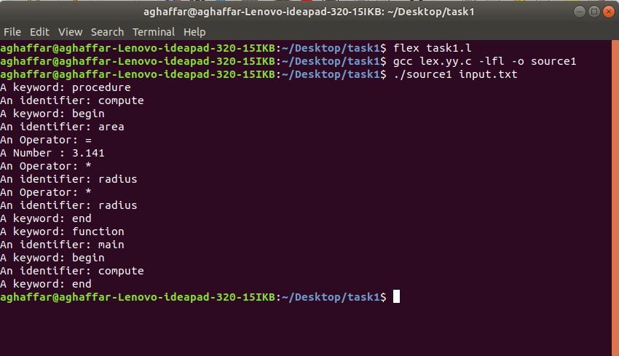

**Source Code task2.l**

**/\*\*\*\*\*\*\*\*\*\*\*\*\*\*\*\*\*\*\*\*\*\*\*\*\*\*\*\*\*\*\*\***

**Task: 2 ~~ Code for PostFix with**

**input string:: 44 33 22 * + 1 -**

**\*\*\*\*\*\*\*\*\*\*\*\*\*\*\*\*\*\*\*\*\*\*\*\*\*\*\*\*\*\*\*\*/**

**%{**

**// #define stack_size 5**

**static int indexStack, stackValue [5];**

**int counter1 = 0;**

**//function for pushing values.**

**static void func_pushValues (int func_arg) {**

**//condition for checking stack size to be less than 5**

**if (++indexStack<5) {**

**//insert into stack**

**stackValue[indexStack]= func_arg;**

**}**

**}**

**//printing function.**

**static void print() {**

**//loop until less than value.**

**for(counter1 = 0;counter1<5;counter1++){**

**printf("%d ",stackValue[counter1]);**

**}**

**printf("\n");**

**}**

**//pop all the values of the stack function**

**static int stackPOP (void) {**

**if (indexStack>=0) {**

**indexStack = indexStack;**

**int temp = stackValue[indexStack];**

**stackValue[indexStack] = 0;**

**indexStack = indexStack -1;**

**return temp;**

**}**

**}**

**%}**

**%%**

**[0-9]+ {func_pushValues (atoi(yytext));print();}**

**"+" {func_pushValues (stackPOP() + stackPOP());print();}**

**"-" {int right= stackPOP(); func_pushValues (stackPOP() - right);print();}**

**"*" {int first = stackPOP();int second = stackPOP(); int product = first*second; func_pushValues(product);print();}**

**"/" {int right= stackPOP(); func_pushValues (stackPOP() / right);print();}**

**"\n" {printf ("Result = %d\n", stackPOP());}**

**[ \t\n] ;**

**%%**

**//drive function**

**int main (void) {**

**indexStack= -1;**

**yyin = stdin;**

**printf("Input Value:: \t");**

**yylex();**

**}**

**OUTPUT**

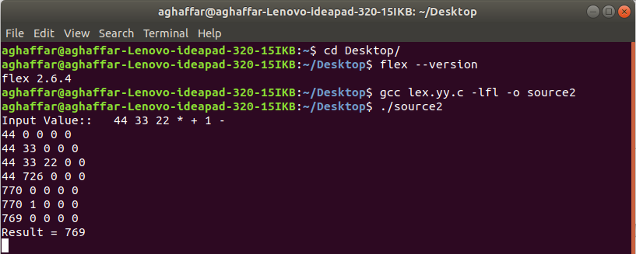

**Deliverables**

You are required to upload your task (Sources & PDF document) using the link created on LMS followed by a viva.